# North-South-University-logo-03.png

CSE 299 Junior Design Project Proposal

# Topic: Android Guided Arduino Mini Bluetooth Smart Car 2.0

## Submitted To:

Md. Shahriar Hussain

Department of Electrical and Computer Engineering

North South University

## Submitted By:

Khadizatul Kubra – 1620070042

Mohammad Bin Khasru –

Rafid khan -

Motivation:

For this project we need to design an android interface, arduino bot and write program in to the arduino microprocessor. Arduino car contains arduino microcontroller with basic mobility features. Arduino programs contains instructions mediating between android controller and Arduino car. Android mobile controller uses different mobile sensors to supervise motion. An appropriate program in the arduino microprocessor to interact with the android controller has to be created.

The program has been successfully complied through arduino IDE to the arduino microprocessor & loaded in to it after proper checking of logic to decrease any loss/damage of hardware. We have to create an android application that will provide user an interface to interact with the arduino powered car. The interface is easy to use and provide feedback from the arduino microprocessor through the bluetooth after giving instruction to arduino for various actions through interface via bluetooth module. The android application is to create with the help of android studio that provide us with more capability & stability. After doing all of this we have test this project thoroughly and find the maximum no. of error & wrong logic in the microprocessor program. After doing this only we can say that we have been able to create as per our goal described.

# Timeline:

3 or 4 months

# Tools Platform:

Software used S/W Tool: Android Studio Operating System: Windows 7 (x86 & x64) S/W

Tool:

* Arduino IDE Hardware requirements
* Android Operating System (2.3.3 – 4.4.4)
* 1.0GHz or faster processor
* 256 MB RAM minimum
* Minimum 500MB of available hard disk space
* Arduino Uno R3 microprocessor
* Arduino Uno shield L298
* Motor shield Stepper motor
* Servo motor
* Bluetooth module- class II
* Ultrasonic sensor 5-8V
* External Power Source/Battery

# Circuit Diagram:

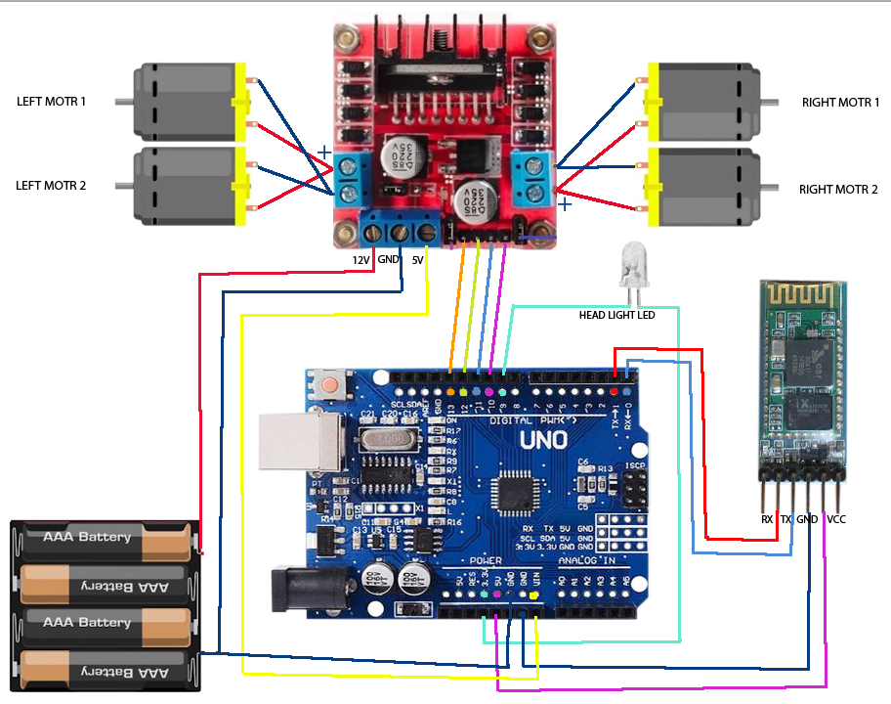

# Approximate Cost Unit: